Shapes

Information Not enough, let's have a look on the columns and their data types using detailed info function

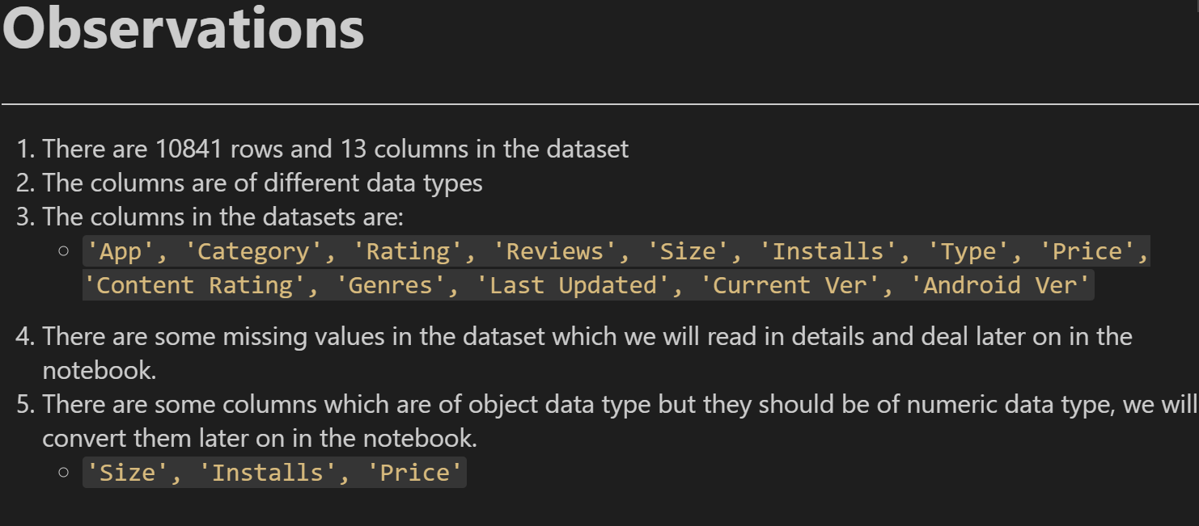

Describe

